Mauritius

04 Nights and 05 Days

CONFIRMED DEPARTURE DATES: 2026
12th & 24th May 2026
12th & 24th June 2026
12th & 24th July 2026
03rd & 24th August 2026
03rd & 24th September 2026
12th & 24th October 2026
12th & 26th November 2026
12th December 2026
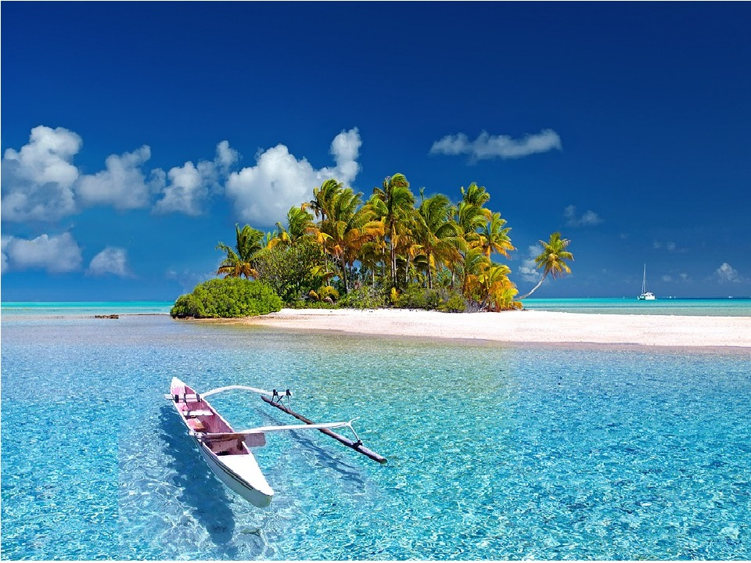

Where You Go | What You See
MAURITIUS – 04 nights  4 Star Hotel | North Tour to Citadelle Fortress, Caudan Waterfront via Port Louis City tour  South Tour to Trou aux Cerfs Crater, Grand Bassin Sacred Lake & Shiv Temple, 23 Colored Earths  Ile Aux Cerf Tour covering water activities on own at Belle Mare + Ile aux Cerfs Island with combined Speedboat transfers and land transfers
Entrance fee included

What is the weather like?
City | Jan |  | Feb |  | Mar |  | Apr |  | May |  | Jun |  | Jul |  | Aug |  | Sep
 | H | L | H | L | H | L | H | L | H | L | H | L | H | L | H | L | H | L
Mauritius | 31° | 26° | 31° | 26° | 30° | 24° | 30° | 24° | 28° | 21° | 27° | 20° | 24° | 19° | 25° | 19° | 26° | 20°

Oct |  | Nov |  | Dec
H | L | H | L | H | L
28° | 21° | 29° | 20° | 30° | 24°

What You are Paying For
International air ticket from Bangalore and return by Indigo airlines or Similar
Meet and assist at the airport at Gate no 7 in public arrival lounge by our Representative
Return airport transfers on Private Basis
4 Nights Accommodation in Double Occupancy with Breakfast & Dinner
All tours & transfers on private basis as per itinerary
Ile aux Cerfs Island with combined Speedboat transfers and land transfers on Private basis
Meal plan as mentioned in the itinerary
Applicable GST

What Is Not Included
Early check in
All day Lunches
Tipping for Guide & Driver
Camera fee (still or movie)
Optional, suggested, or unspecified activities
Any expenses of personal nature such as Porterage, Laundry, and Alcohol, Food or Drink not in the regular menus provided by us, mini bar and telephone calls
Any extra meals not included in the itinerary. Meals are pre - set and a choice of menu is not available
Anything which is not specified in the Itinerary

This is where you are likely to stay
City | Probable Hotel Name
Mauritius | Anelia Beach Resort & Spa (Superior Ocean View Room) or similar

What Will It Cost You?
 | Two of You in One Room
If you are 12 years or older | INR.99,900/- per person

Tour costs shown here are subject to change without notice. Check the updated tour cost with Turnkey Holiday executives before booking. Any aspect of this tour is subject to change without notice.

This Includes:
The above quote is valid for 02 adults travelling together,
International economy class air fare of INR 31,000/- per person but the actual air fare at the time of ticket issuance will have to be paid by you.

- Supplement cost for Guaranteed early check in with breakfast INR.8,000/- per person

This Doesn’t Include:
As per the Government of India regulations, Tax Collected at Source (TCS) is applicable on overseas tour packages. A TCS of 2% will be charged on the total tour cost without any threshold limits.

This tax will be collected additionally and is payable by the client at the time of booking. The applicable rates are subject to change as per prevailing government guidelines.

We need a copy of your PAN card if you pay us more than INR 49,900 in cash and can’t accept more than INR 1,99,000 in cash for this tour.

Your Flight Departs From Kempegowda International Airport at 03:20 Hrs
You will Arrive at Sir Seewoosagur Ramgoolam International Airport at 07:45 Hrs
Indigo airlines - 6E-1861 BLRMRU 03:20 07:45

Day 01: Arrive Mauritus
Meet and assist at the airport by our airport Representative at Gate No.7
Transfer to Hotel
15:00 hrs Check in Hotel & relax
Overnight stay at Hotel
MEAL PLAN: D

Day 02: North tour
After breakfast; Drive to Floreal for duty free shopping at the Diamond factory, Ship model factory and other branded duty-free items. Afterwards transfer to Citadelle fortress passing by The Champ de Mars (Horse Race Ground), Port Louis theatre, Government House, then direction to the Port Louis Caudan Waterfront Shopping Complex where you can do your shopping either at its multiple complex or at the old market nearby or simply enjoy the magnificent view of the harbor with a visit to the Kuan Fu Tea Factory.
Lastly, you will be dropped at Jumbo Shopping Mall where you can also enjoy varieties of delicious foods at the spacious food court and shopping at Branded Shops around or buy usual daily stuff from the Hypermarket.
Drive back to the Hotel & Overnight stay at Hotel
MEAL PLAN: B | D

Day 03: Ile Aux Cerfs tour
After breakfast; Drive to Belle Mare where you can enjoy water activities such as undersea walk, Parasailing, Tube ride, Waterfalls visit at a supplement cost. Afterward, Drive to Trou d’EauDouce and get a speedboat transfer to
Ile aux Cerfs (a small island of 7Kms diameters off the east coast of Mauritius).
Free on island up to 16:00hrs then get your speedboat transfer back to Trou d’EauDouce and drive back to hotel.
(Swimsuit, Short & T-shirt, Spare clothes, Beach Towel, Sun block, Sunglasses, Cap, and Slippers are compulsory).
Overnight stay at Hotel
MEAL PLAN: B | D

Day 04: South tour
After breakfast; Drive to Vallé Adventure Park with its 4 waterfalls (entrance fee included) The Valley of 23 Colored where you can have your lunch and various activities like Quad biking, zip lining, Jeep visit, Nepalese Bridge, etc (On your own) Then drive to Grand Bassin (Ganga Talao) sacred lake & view the stunning 108 feet statue of
“Mangal Mahadev”. Afterwards, proceed to Trou aux Cerfs Crater for a panoramic view of Curepipe City then stop. Lastly, you will be dropped at Riche Terre Mall or Carrefour Phoenix Mall where you can also enjoy varieties of delicious foods at the spacious food court and shopping at Branded Shops around or buy usual daily stuffs from the Hypermarket. Drive back to the hotel. (Sportswear, Sports shoes, Cap, Mosquito Repeller are compulsory for those opting for activities).
Meal Plan: B | D

Day 05: Mauritius - Departure
Breakfast at the Hotel
Check-Out from Hotel
Transfer to Airport to board flight by Indigo airlines
6E-1862 MRUBLR 09:30 17:00
Meal Plan: B

We Want You To Know This
- Rooms are subject to availability at the time of confirmation
- At Hotels Check in time is 1400hrs and check out is 1200 Hrs.
- Early check in and late check-out is subject to availability and on extra cost.
- Passport should be valid for more than 7 months from the date of return journey
- The exchange rate considered 1USD: - INR90, however any escalation as to be absorbed by the clients themselves
- No refund for Unused services

